Data Analysis Portfolio Project – Music Store Database
Project Title: Music Store Data Analysis: Customer Insights & Business Intelligence
Objective:
To demonstrate advanced SQL capabilities by extracting actionable business insights from a relational music store database. The analysis covers customer behaviour, sales performance, genre popularity, and strategic recommendations for marketing and inventory management.
Tools & Technologies: PostgreSQL, pgAdmin4, SQL (CTEs, Window Functions, Aggregate Functions, Joins, Subqueries)
Database Schema: A standard music store schema including tables such as customer, invoice, invoice_line, track, genre, artist, album and employee.
Key Business Questions & Analytical Approach
The project involved answering 11 critical business questions, moving from basic data retrieval to complex ranking and window operations.
1. Executive & Operational Reporting (Q1-Q5)
- Q1: Senior Most Employee Identification
  - Query: Ordered employees by job levels descending.
  - Insight: Identified the senior-most general manager (Mohan Madan, Level L7), useful for internal communications and hierarchy analysis.
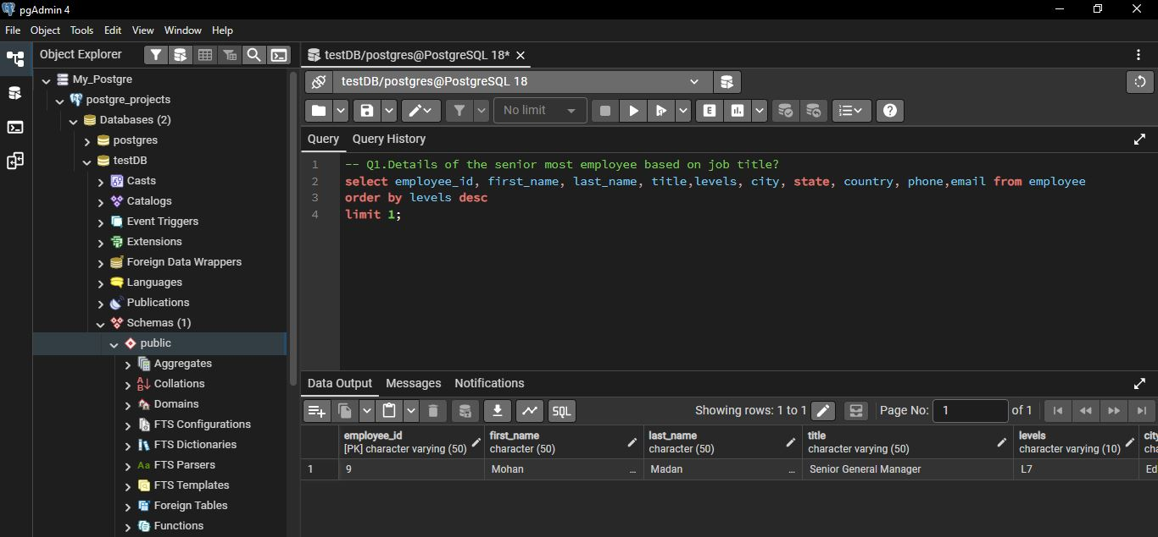
  - Skill: ORDER BY, LIMIT.

- Q2 & Q3: Top Markets & High-Value Transactions
  - Finding: The USA has the highest number of invoices (131), indicating the largest market volume. The top three invoice values are 23.76 and 19.80, highlighting high-ticket sales.
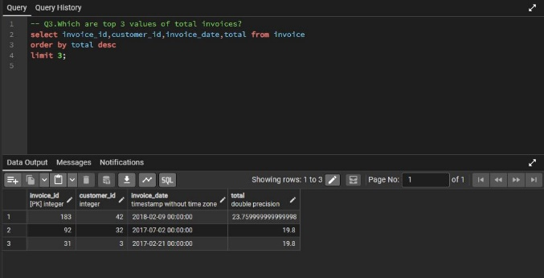
  - Skill: GROUP BY, COUNT(), ORDER BY DESC, LIMIT.
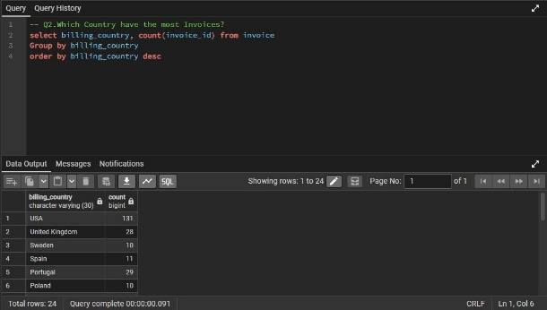

- Q4: Best City for a Promotional Music Festival
  - Query: Summed total spent per billing_city.
  - Result: Prague generated the highest sum (273.24), making it the optimal location for a promotional event.
  - Skill: SUM(), GROUP BY, aggregations.
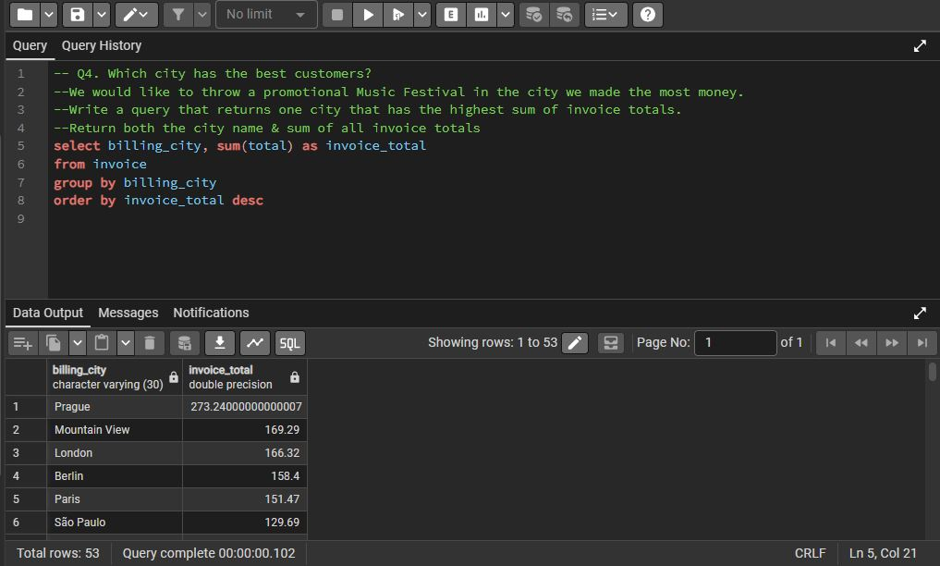

- Q5: Best Customer Identification
  - Query: Joined customer and invoice to sum total spending per customer.
  - Result: Customer R. Madhav (ID 5) is the highest spender (144.54), qualifying for a loyalty program.
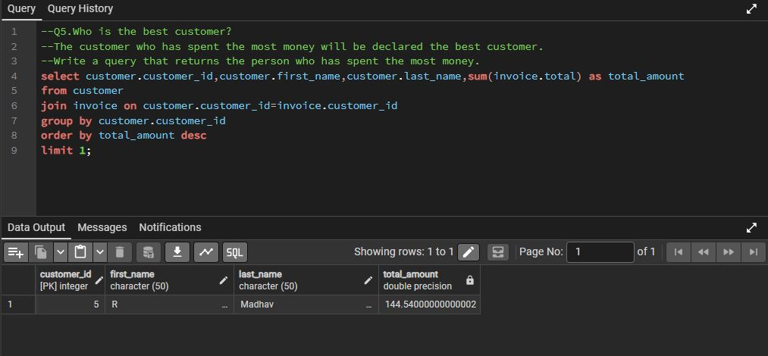
  - Skill: Multi-table join, SUM(), ORDER BY, LIMIT.

2. Genre & Artist Analysis (Q6-Q8)
- Q6: Rock Music Listener Outreach
  - Query: Extracted email, first name, and last name of Rock listeners using a subquery on genre and track.
  - Result: Generated a targeted email list (e.g., Aaron Mitchell, Alexandre Rocha) ordered alphabetically for marketing campaigns.
  - Skill: Subquery, DISTINCT, LIKE, filtering.

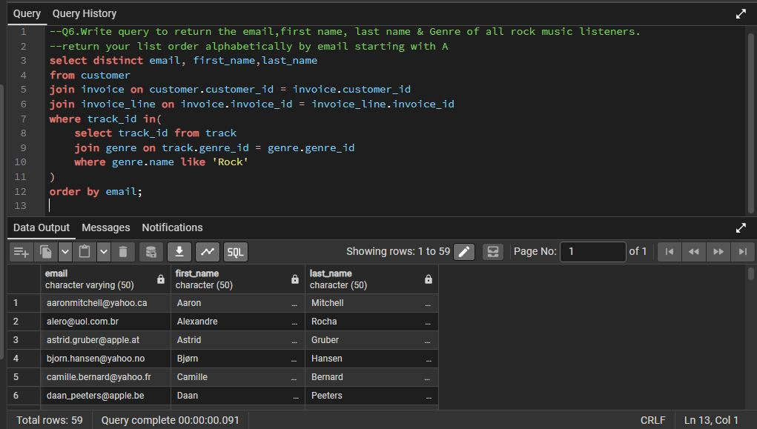
- Q7: Top Rock Bands by Track Count
  - Query: Joined artist, album, track, and genre; filtered for 'Rock'; counted tracks per artist.
  - Result: Led Zeppelin (114 tracks) and U2 (112 tracks) are the most prolific rock bands, making them ideal for a featured promotion.
  - Skill: Multi-join (4 tables), GROUP BY, aggregate functions.
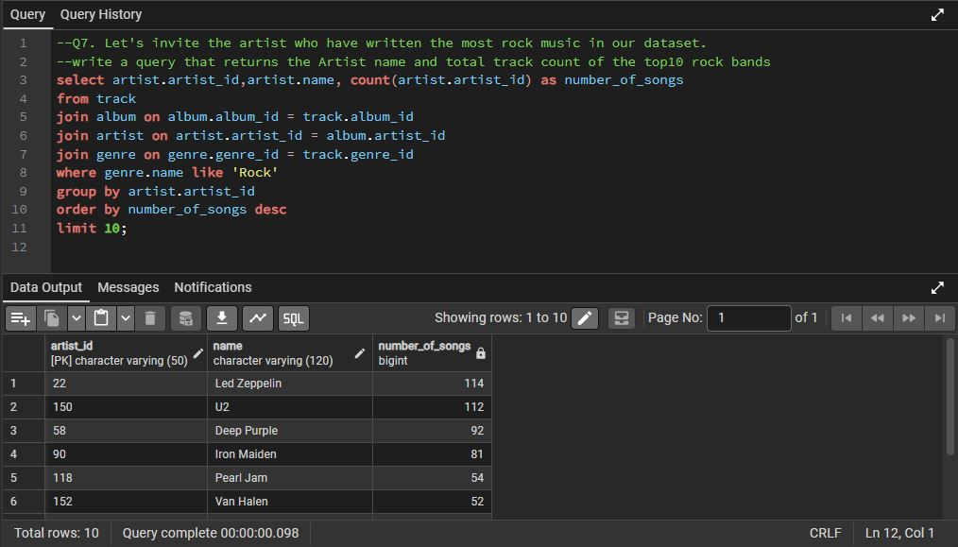
- Q8: Identifying Long Tracks
  - Query: Used a subquery to find tracks with milliseconds > the average song length.
  - Result: Returned 494 tracks, with "Occupation/Precipice" (5,286,953 ms) being the longest. Useful for analyzing content length outliers.
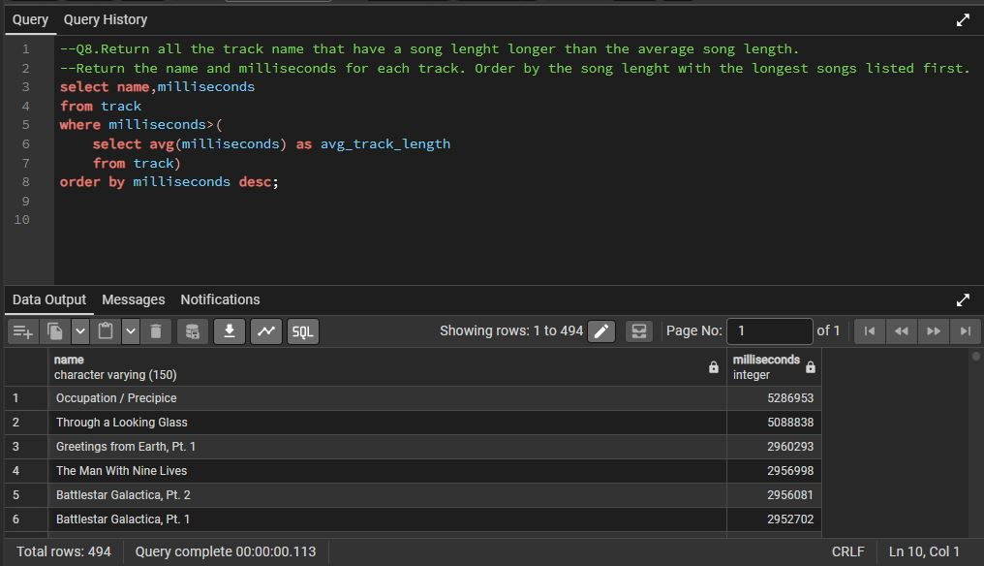
  - Skill: Subquery with AVG(), correlated subquery logic.

3. Advanced Analytics: Window Functions & Ranking (Q9-Q11)
- Q9: Customer Spending per Top Artist
  - Approach: Used a CTE (best_selling_artist) to find the top artist (Queen), then calculated how much each customer spent specifically on that artist.
  - Insight: Customer Hugh O'Reilly spent the most on Queen (27.72). This enables personalized artist-based recommendations.
  - Skill: Common Table Expression (CTE), multi-level aggregation.
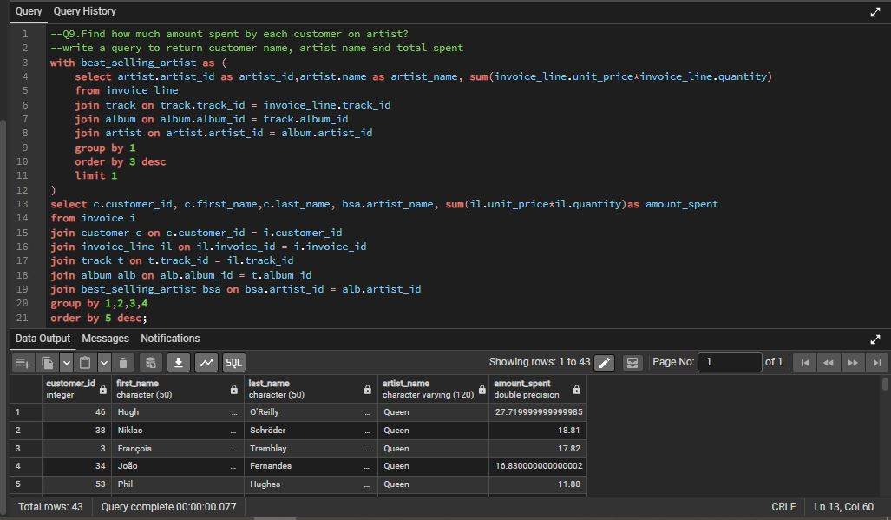
- Q10: Most Popular Music Genre per Country
  - Approach: Used ROW_NUMBER() partitioned by customer.country and ordered by purchase count descending.
  - Insight: Rock is the #1 genre in most countries (USA, Brazil, UK, etc.). However, Alternative & Punk tops in Argentina. This allows for localized genre marketing.
  - Skill: Advanced Window Function (ROW_NUMBER()), PARTITION BY, handling ties (query returns all where RowNo <= 1).
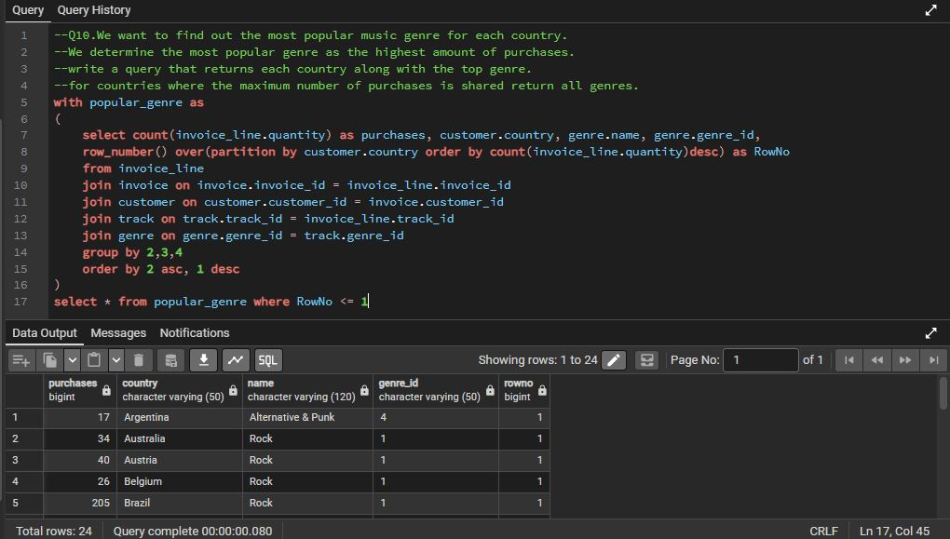
- Q11: Top Customer per Country (Handling Ties)
  - Requirement: Identify the highest spender in each country. If multiple customers share the same max spend, return all.
  - Initial Code (provided): Used ROW_NUMBER() – this arbitrarily picks one customer in case of ties.
  - Critical Improvement for Business Logic: To truly handle shared top spending, RANK() should be used instead of ROW_NUMBER(). A corrected query is provided below.
  - Result from current data: Shows top spenders like Luis Gonçalves (Brazil: 108.90) and Mark Taylor (Australia: 81.18).
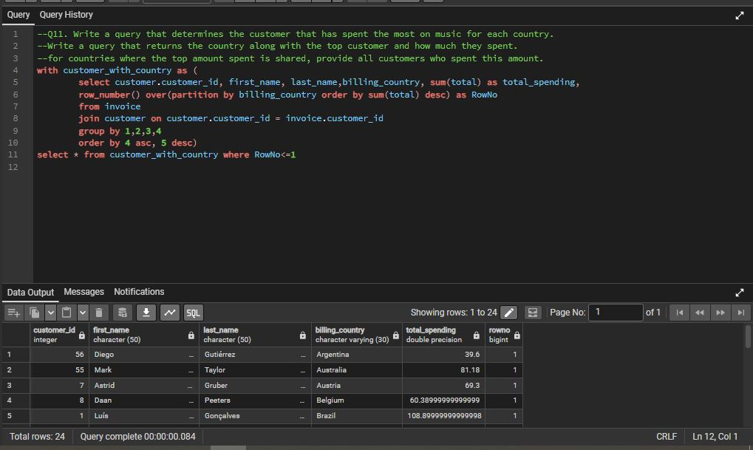
Key Business Insights from the Music Store Analysis
1. Customer & Sales Insights
- Top Spender Identified: Customer R. Madhav spent the most overall ($144.54) – ideal for loyalty rewards or VIP treatment.
- Best City for an Event: Prague generated the highest total invoice sum ($273.24), making it the best location for a promotional music festival.
- Largest Market by Volume: USA has the most invoices (131), indicating the highest transaction volume.
2. Music Genre & Artist Trends
- Dominant Genre Globally: Rock is the #1 most purchased genre in the majority of countries (USA, Brazil, UK, Canada, etc.).
- Localized Preference: Alternative & Punk ranks top in Argentina – suggesting region-specific genre marketing.
- Most Prolific Rock Artists: Led Zeppelin (114 tracks) and U2 (112 tracks) have the highest number of rock songs in the database – top candidates for featured promotions.

